ELECTRONIC VOTING SYSTEM

Presenter name: Gabriella Laura

Index number:

Institution: Institute of Advanced Technology

Supervisor:

Submitted to KNEC for award of: Diploma in ICT module 3 ,July 2021

Date:

# Dedication

i dedicate this project to those that helped me dream up this opportunity my mother who's been with me every step of the way, and my lecturers for guiding me in this endeavor.

# Declaration

I declare that this work is real, original and undertaken by me, no plagiarism was involved.

Name:

Sign:

Declaration by the supervisor that the candidate’s work is original and that the candidate received appropriate supervision (declarations must be signed)

Name:

Sign:

Contents

Dedication 2

Declaration 2

ABSTRACT 5

CHAPTER 1: INTRODUCTION 6

Background information 6

Problem statement 6

Objectives 6

Significance 7

Scope 7

Chapter 2: LITERATURE REVIEW 8

Discussions of existing design 8

Critique of existing design 8

Evaluation of proposed design 9

Challenges and benefits 9

Summary of gaps identified 9

CHAPTER 3: METHODOLOGY 10

Requirements 10

Analysis 11

Design 11

Coding 11

Testing 11

Maintenance 11

CHAPTER 4: SYSTEM ANALYSIS AND DESIGN 11

12

13

CHAPTER 6: LIMITATIONS, CONCLUSION AND RECOMMENDATION 14

Limitations 14

Conclusion 14

Recommendation 14

CHAPTER 7: REFERENCES 15

CHAPTER 8: APPENDIX 15

# ABSTRACT

The study examined the use of an online voting system; thus, the importance of a voting system can not be overemphasized in any country as the government. It needs to embark on effective systems to effect proper monitoring, control and user satisfaction. In this regard voting systems can be seen as a process of ensuring record keeping for future reference, monitoring votes as they are counted among other functions. The current system is a security risk as has been seen by previous election. This system automates the voting scene making it secure, fast and efficient thus one need not wait a whole two days to figure out who won and any election irregularities claim would be baseless thus would avoid a post-election violence like the happenings of 2008. The system is a fairly simple yet sophisticated system that allows for cloud storage that would store the registered voter’s names in case the database fails, the system is easy to navigate this allows anyone to know how the user interface of the system works without actually having prior knowledge and once a vote is cast, once account is deactivated meaning no double votes can be cast allowing for the integrity of the system. This project is built to provide ease of access and ease of mind to voters both home and abroad and if adopted by the country will save the country a lot since it negates half of the spending the country uses.

# CHAPTER 1: INTRODUCTION

## Background information

Typically voting systems in the country have been manual, process of going to vote long and taking up the whole day, then comes the counting which takes a minimum of 2 days and the process is rarely trusted by those that cast the votes, hence leading to discourse and conflict. An automated electoral system restores faith in the voting scene while cutting the time by more than half and ensuring truly free and fair election.

## Problem statement

Main problem faced by people voting manually are:

* Much time is required for the casting of votes process
* Election irregularities
* A lot of time used in counting votes

## Objectives

* An electronic voting system hopes to speed the speed of counting ballots
* Aims to reduce cost of paying staff to count votes manually thus reducing long term expenses
* Aims to improved accessibility for disables voters
* Voters get to save time and cost by voting independently from their location which may increase overall voter turnout
* Citizens living abroad have access to voting services wherever they are

## Significance

Voting is a civic duty that allows the citizens of a nation to choose the leaders they want to lead them through a given period of time. A voting system that allows free, fair seamless elections allows them to practice their rights without fear of election irregularities, fear of oppression which allows people from all walks of life to live freely knowing they elected a leader of their choice without being silenced and an added bonus they did this within the comfort of their own home on their laptop or phone

## Scope

This system provides a better way of election between people and political parties; hence this project has a greater scope and is an important requirement to provide a compact, stable system of a voting facility anywhere in the country

# Chapter 2: LITERATURE REVIEW

## Discussions of existing design

The existing system, a manual system, involves registering for a voter’s card first. This process expects one to be a citizen of the country that one is voting for. On the day of election, one queues in line to get the chance to vote on a ballot paper specially printed from neighboring countries, one then casts his/ her vote into a ballot box which are secure boxes only opened at the polling station after all votes have been cast. Once the voting process is done, officials manually count the votes and send data to a central location where the numbers are tallied and the leading candidate announced when all votes are tallied.

## Critique of existing design

* The existing system has a lot of wasted time registering voters all around the country; this process also requires labor fees for all the people registering voters.
* The existing system is expensive as a lot of equipment is imported from other countries
* Ballot papers are made from cut trees which negatively affects the eco system hence fast-tracking global warming
* For citizens outside the country at the time of voting, they do not have access to voting amenities, this means they have no say on who rules their country
* Election irregularities such as forged votes are a common phenomenon in this way of voting
* Overall costs of a manual election such as hiring people, importing ballots, disposing of ballots

## Evaluation of proposed design

The proposed design is an electronic system working on smart devices that allows one to register from the comfort of anywhere, log into the system, vote for a preferred candidate and leave the system in less than five minutes. The system tallies the cast votes simultaneously as voters cast them, thus allows for the leading candidate to be announced by the end of the day, this is faster

## Challenges and benefits

The proposed system has its challenges and its benefits, they are as follows

#### Challenges

* Since the system is electronic, it can be hacked
* The system needs constant maintenance

#### Benefits

* The system is cheaper to run
* The system is faster
* The system reduces waste
* The system is more convenient for people with disabilities and those outside the country
* The system can be widely used including overseas

## Summary of gaps identified

The gaps identified in the system are minor and can be solved with a stable security system and proper maintenance

# CHAPTER 3: METHODOLOGY

REQUIREMENTS

ANALYSIS

DESIGN

CODING

TESTING

DEPLOYMENT

MAINTENANCE

To create the system, I employed the use of waterfall methodology which is commonly used for its ease and order while creating a system

## Requirements

* A laptop; to work on and store the work
* A steady internet connection for extensive research
* Sublime text; a sophisticated text editor for code, markup and prose

## Analysis

An overview of the existing system: the system in place is a physical system that allows the user to register as a voter of a certain area; this allows the voter to vote for a candidate of his choosing and when done, the voter is marked and can’t vote twice.

An overview of the new system: the new system is an electronic system that allows the user to log into the system electronically, and cast a vote from wherever, the system will automatically calculate and render results

## Design

The system was to be easy to access, and efficient in all matters overall

## Coding

Coding the system took a total of five months using html, css and a bit of php to connect to a database

## Testing

The testing phase was done over a period of one week, bugs found were fixed.

## Maintenance

The maintenance is basically ensuring the system is running smoothly throughout .

# CHAPTER 4: SYSTEM ANALYSIS AND DESIGN

Simple diagrams to show how the system works:

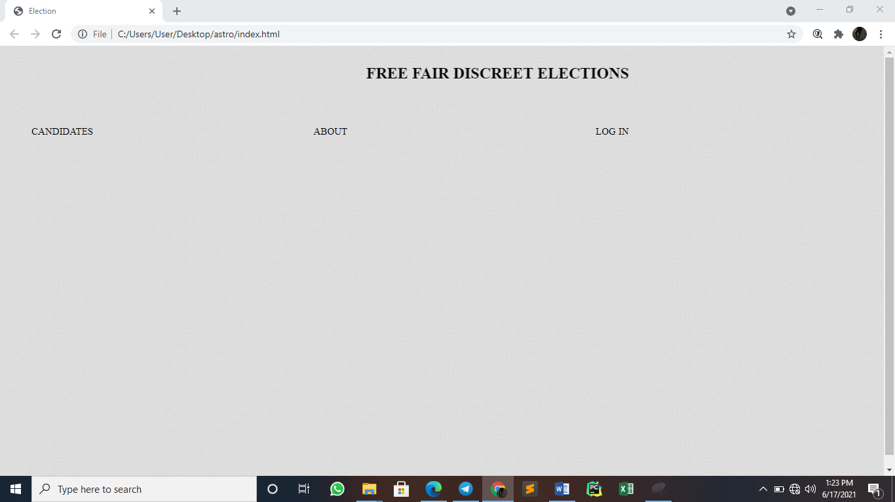

Figure :the landing page

Once you enter the site, you get this as the landing page.

# 

Figure :the about candidates’ page

This page is for people who’d like to know more about the candidates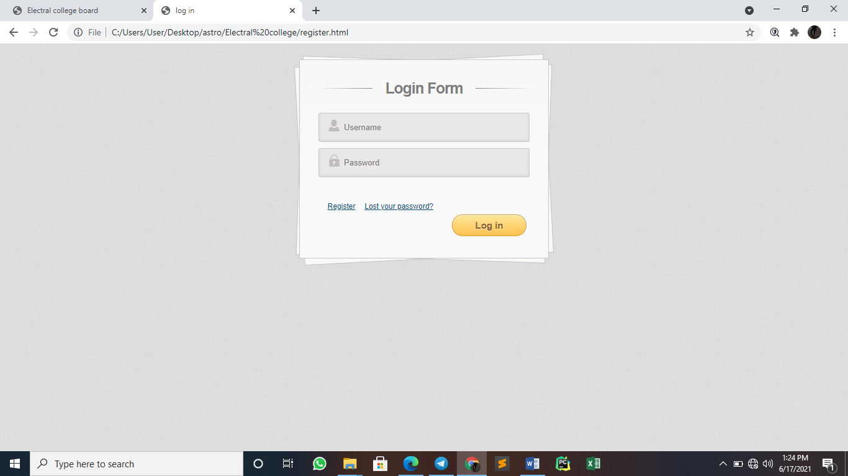

Figure : log in page

The log in page sends you to the voting page where one is allowed to vote

# 

Figure :registration page

The registration page allows voters to register as voters

# 

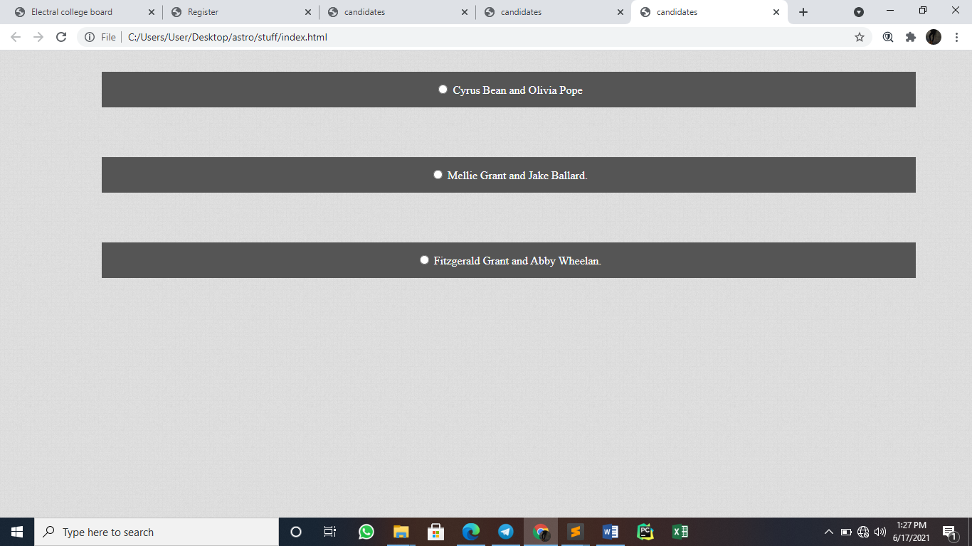

Figure :voting page

# CHAPTER 6: LIMITATIONS, CONCLUSION AND RECOMMENDATION

## Limitations

During creation of a system there are bound to be some obvious constraints, a survey shows that majority of the public do not trust technology and without trust from the public, the system’s results would be greatly disputed; this would force us back to the age of physical voting

## Conclusion

The system is entirely plausible if we earn the trust of the general public and make sure the system is secure, this would reduce the spending budget on elections drastically

## Recommendation

The system might need a few updates over time but it’s a generally efficient and secure system that would revolutionize the country’s voting scene

# CHAPTER 7: REFERENCES

*The future of election administration by Michelle Brown Palgraves.*

*Securing American elections: how data driven election monitoring can improve our democracy by Dr. Seo-Young Silvia Kim*

*Brave new ballot, battle to safeguard democracy in the age of electronic voting by Aviel Rubin*

# CHAPTER 8: APPENDIX

Waterfall methodology-breakdown of a project into a linear sequential phase

Html-Hypertext markup language is the standard markup language for documents designed to be displayed by a web browser.

CSS- cascading style sheet is a style sheet language used for describing the presentation of a document written in markup language such as html.

Php-scripting language best suited for web development.

Database-a structured set of data held in a computer, especially one that’s accessible.

QUESTIONAIRE

Are you familiar with the current voting system?

* Yes
* no

(*if yes*) What are your thoughts on the current voting system?

Are you familiar with online voting systems?

* + Yes
  + No

Would you use an online voting System? (*give reasons why for each answer*)

What voting system would you prefer and why?